Day 0

Introduction to python

**Python:-**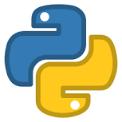

Python is a high-level, interpreted, and general-purpose programming language.

It was created by Guido van Rossum and first released in 1991.

Python is known for its simplicity and readability, which makes it an excellent choice for beginners and experienced developers alike.

Some key features and characteristics of Python include

1)Readable and Expressive Syntax: Python's syntax is designed to be easy to read and write. It uses indentation (whitespace) to define code blocks, making it more visually intuitive.

2)Interpreted Language: Python is an interpreted language, which means that you don't need to compile your code before running it. This makes development faster and more interactive.

3)High-Level Language: Python provides high-level abstractions that allow developers to focus on solving problems rather than dealing with low-level details.

4)Cross-Platform: Python is available for a wide range of platforms (Windows, macOS, Linux) and can be used to develop cross-platform applications.

5)Large Standard Library: Python comes with a vast standard library that includes modules and packages for a wide range of tasks, from file handling and networking to web development and data analysis.

6)Dynamically Typed: Python is dynamically typed, which means that you don't need to declare variable types explicitly. The interpreter infers the type of a variable at runtime.

7)Object-Oriented: Python is an object-oriented programming (OOP) language, which means it supports the creation and manipulation of objects, making it suitable for building complex software systems.

8)Extensible: You can easily extend Python by writing modules in other languages like C or C++, making it versatile for various use cases.

9)Community and Ecosystem: Python has a vibrant and active community of developers. There is a vast ecosystem of libraries and frameworks for various purposes, including web development (e.g., Django, Flask), data science (e.g., NumPy, Pandas), machine learning (e.g., TensorFlow, PyTorch), and more.

10)Open Source: Python is an open-source language, which means it's freely available and can be used, modified, and distributed without licensing costs.

Reason to Learn Python

### Career Opportunities and Salary

-most of the big companies used python

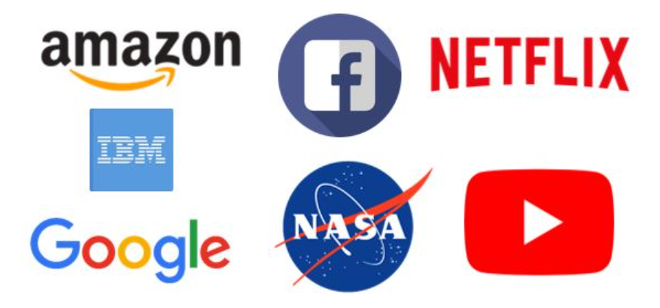

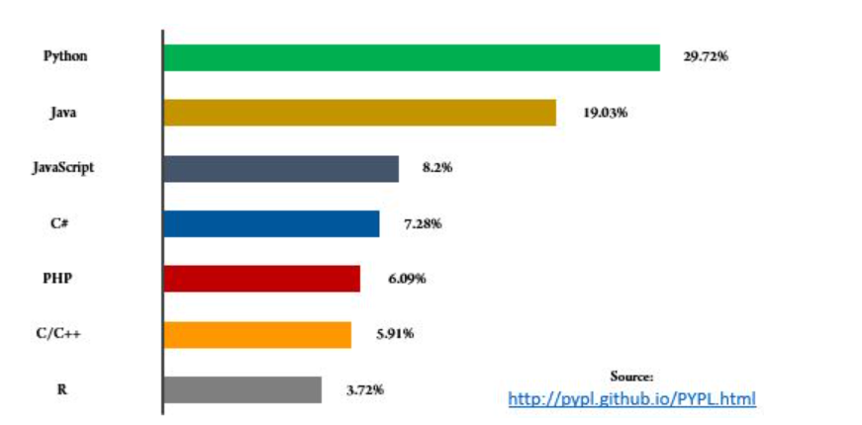

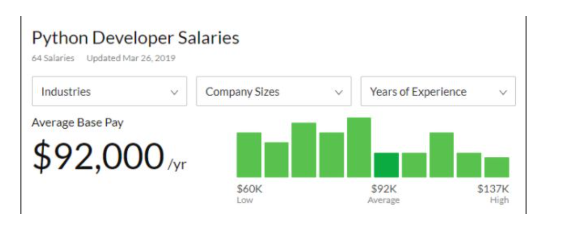

### Data Science

-A large number of libraries is availabe for Data Science

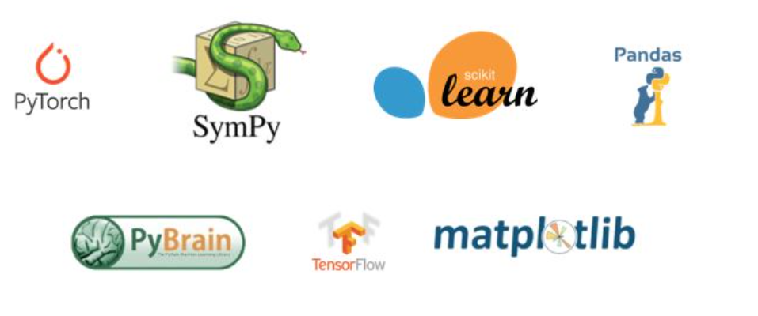

### Machine Learning

- all machine learning task are performed using python

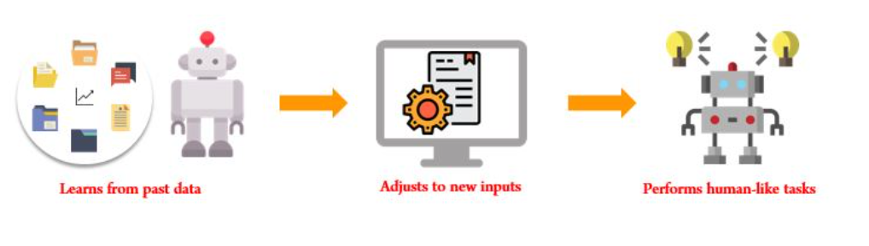

### Web Development

-Python can be also used for web development

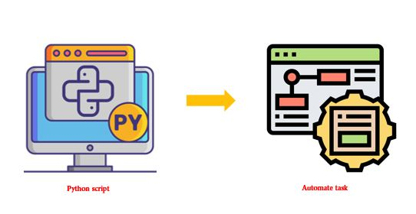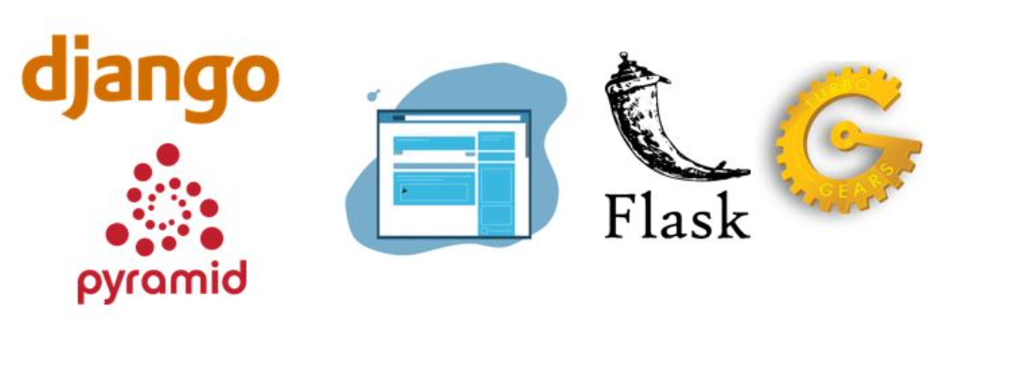

### 5. Scripting and Automation

### Libraries and Packages

Python have the largest libraries as compared to other programing language

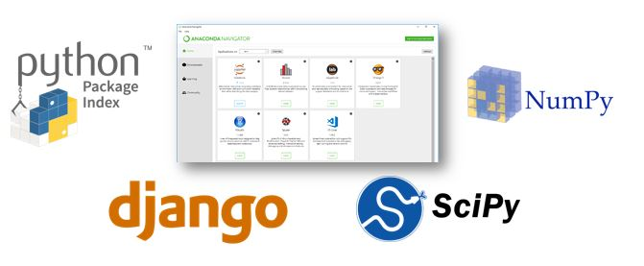

### 7.  Portable and Extensible

### IMG_256

### Active Community

- Largest Programing Community

